EXPERIMENT NO:05

Aim:
Implement Denial-of-Service(Dos) attack to make the network resources unavailable using python script.

Software Required :
hping3, ettercap,Kali Linux

Theory :
1.Denial of Service(Dos):
A denial of service (DoS) attack is an incident in which a user or organization is deprived of the services of a resource they would normally expect to have. In a distributed denial-of-service, large numbers of compromised systems (sometimes called a botnet) attack a single target.
Although a DoS attack does not usually result in the theft of information or other security loss, it can cost the target person or company a great deal of time and money. Typically, the loss of service is the inability of a particular network service, such as e-mail, to be available or the temporary loss of all network connectivity and services. A denial of service attack can also destroy programming and files in affected computer systems. In some cases, DoS attacks have forced Web sites accessed by millions of people to temporarily cease operation.

2.Hping3:
hping is a command-line oriented TCP/IP packet assembler/analyzer. The interface is inspired to the ping(8) unix command, but hping isn't only able to send ICMP echo requests. It supports TCP, UDP, ICMP and RAW-IP protocols, has a traceroute mode, the ability to send files between a covered channel, and many other features.

While hping was mainly used as a security tool in the past, it can be used in many ways by people that don't care about security to test networks and hosts. A subset of the stuff you can do using hping:
- Firewall testing
- Advanced port scanning
- Network testing, using different protocols, TOS, fragmentation
- Manual path MTU discovery
- Advanced traceroute, under all the supported protocols
- Remote OS fingerprinting
- Remote uptime guessing
- TCP/IP stacks auditing
- hping can also be useful to students that are learning TCP/IP.

3.ettercap:
Ettercap is a comprehensive suite for man in the middle attacks. It features sniffing of live connections, content filtering on the fly and many other interesting tricks. It supports active and passive dissection of many protocols and includes many features for network and host analysis.

Procedure :
1. For Ping :
1.1 Open Terminal and Type ping <ip_address_of_target> -s <packet_size> -f
-f - Set Don't Fragment flag in packet
-s - packet size

2. For hping3 :
2.1 Open terminal and type hping -c 10000 -d 120 -w 64 -p 21
--flood –rand-source <ip_address _of _target>
2.1 if you see hping in flood mode then the site can be attacked using dos. If you See some unresolvable issue it simply mean it has some kind fo firewall.
3. Using Etter cap :
3.1 Open terminal and type ettercap -G and hit enter.
3.1 From the menu bar select Sniff→ Unified sniffing.
3.3 Select network interface.
3.4 from the Menu bar select plugins→ Manage plugins→ select dos-attack from the list. Enter ip address and fake ip address.

Conclusion :

OUTPUT:
1.Ping of Death:

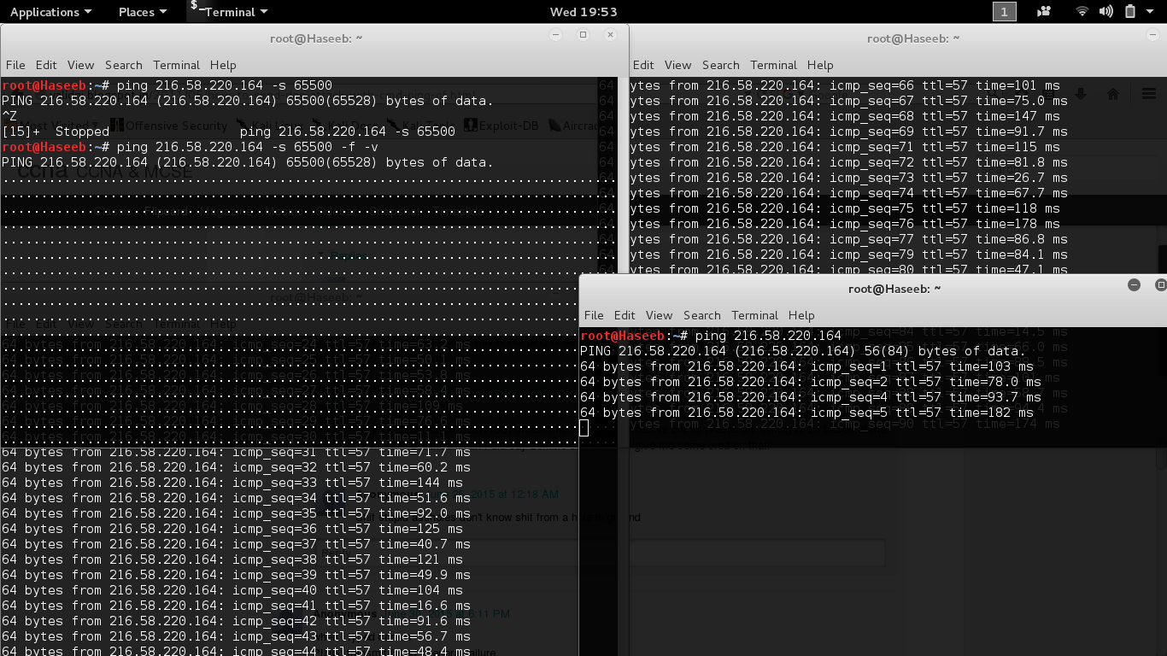

2. Hping
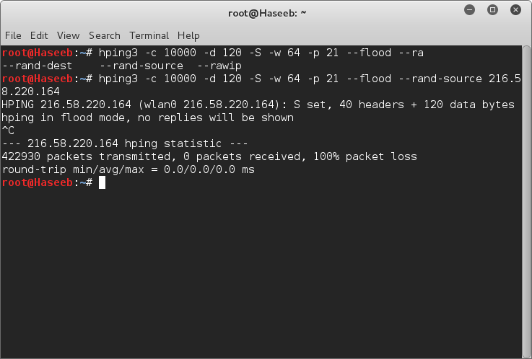

3.

ettercap
